Milborne Port Surgery - July 2021

Name of controller | Milboren Port Surgery
Subject of DPO | Video consultations using AccuRx
Name of DPO | Kevin Caldwell, Somerset CCG  somccg.GPDPO@nhs.net

The use of AccuRx platform for video consultations between healthcare staff and their patients. This can be initiated via a secure URL by healthcare or social care staff. Patients do not need to download an app or create an account.

In the video consultation, the clinician will record the observations and outcome of the consultation in the same way as a face-to-face consultation is recorded in the patient’s electronic primary care record and any agreed actions are carried out.

The health organisation remains the data controller, and AccuRx the data processor, as per AccuRx’s existing Data Processing Agreement. The video consultation service is hosted by Whereby who are fully compliant with GDPR. The video and audio communication is only visible to participants on the call and is not recorded or stored on any server. The connection prioritises ‘peer-to-peer’ between the clinician’s and patient’s phone and follows NHS best practice guidelines on health and social care cloud security.

A unique URL to the video consultation is generated and all participants are visible in the consultation, no third party can “listen in”. The video and audio communication of the video consultation is only visible to participants on the call, and is not recorded or stored on any server (not AccuRx’s, not Whereby’s and not on any third party’s servers). Whereby are based in the European Economic Area (EEA). All communication between the user’s browser, or the patient’s browser, and Whereby’s service is transmitted over an encrypted connection (secure web traffic using HTTPS and TLS or secure websocket traffic or secure WebRTC). Furthermore, the video consultation connection prioritises ‘peer-to-peer’ connections between the clinician’s and patient’s phone over connections via their servers. In some cases, due to NAT/firewall restrictions, the encrypted data content will be relayed through Whereby’s TURN server, but never recorded or stored. In such cases, as long as both the clinician and patient are using their computer devices in the European Economic Area, it is guaranteed that any data hosted on a server is within the EEA in line with NHS best practice guidelines on health and social care cloud security.

The only data related to the call that may be stored by Whereby is metadata to provide additional context about the way their service is being used. The usage data may include call participant’s browser type and version, operating system, length of call, page views and website navigation paths, as well as information about the timing, frequency and pattern of the service use. The IP address of call participants may also be stored as part of this usage data. No other personal information of call participants is collected or stored by Whereby.

The nature of the relationships with the individuals participating in any video consultations is identical to that of face-to-face consultations between clinicians and their patients. In the video consultation the clinician will record the observations and outcome of the consultation in the same way as a face-to-face consultation is recorded in the patient’s electronic primary care record and any agreed actions are carried out.

The use of video consultation via AccuRx is more secure than speaking to patients by phone. The connection prioritises ‘peer-to-peer’ between the clinician’s and patient’s phone in line with the principal of data minimisation. Most phones are Voice over Internet Protocol (VoIP). However, phone connections typically include personal information (such as patient phone number). In contrast, the AccuRx video consultation does not use any personal demographic information as it is initiated via a unique URL which does not use any patient or user information. AccuRx specifically selected Whereby services to host video consultations because it fulfilled AccuRx privacy by design requirements in not using any personal demographic data for the calls.

The purpose of using video consultations on the AccuRx platform is to minimise face-to-face contacts between healthcare staff and their patients as advised by NHS England on 5th March 2020 in the delivery of healthcare.

Views have been gathered from AccuRx users across 3,500 GP practices. Over 1,300 practices have completed 2,000 video consultations in the 48 hours (since March 9th) using AccuRx.

The lawful basis of healthcare staff performing consultations via video with patients is the provision of health care or social care services:
6(1)(e) ‘… necessary for the performance of a task carried out in the public
interest or in the exercise of official authority …’.
9(2)(h) ‘… medical diagnosis, the provision of health or social care or
treatment or the management of health or social care systems…’

Data Protection Act:
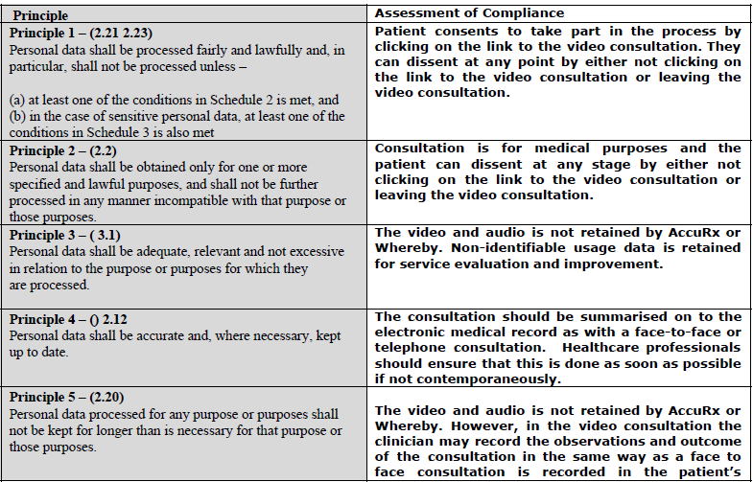
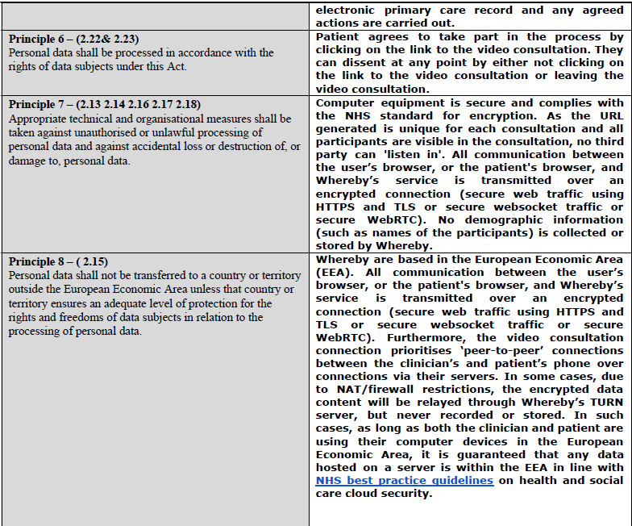

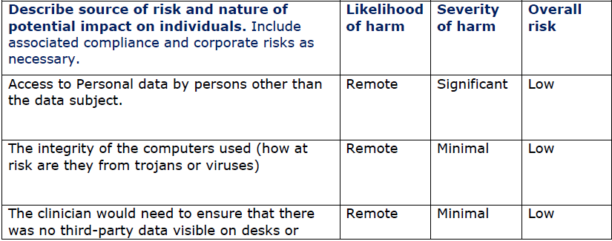
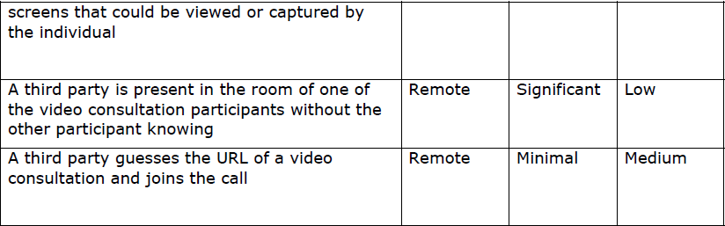
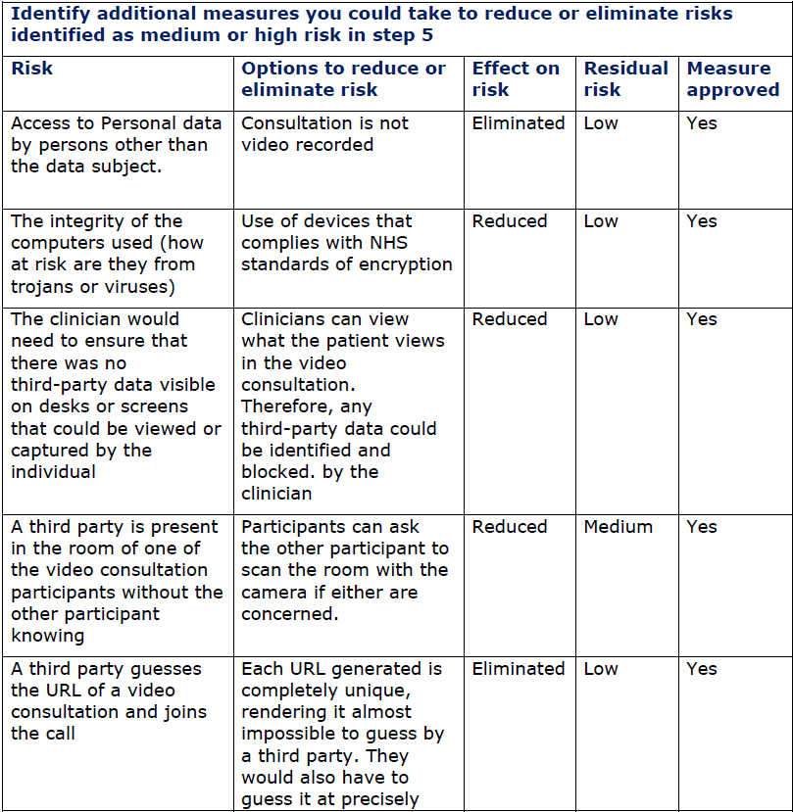

Item | Name/position/date | Notes
Measures approved by: | Partners 07.5.20 | Integrate actions back into project plan, with date and responsibility for completion
Residual risks approved by: | Partners 07.5.20 | If accepting any residual high risk, consult the ICO before going ahead
DPO advice provided: | N/A | DPO should advise on compliance, step 6 measures and whether processing can proceed
Summary of DPO advice:
DPO advice accepted or overruled by: | N/A | If overruled, you must explain your reasons
Comments
Consultation responses reviewed by: | N/A | If your decision departs from individuals’ views, you must explain your reasons
Comments:
This DPIA will be kept under review by: | Linda Bickerton | The DPO should also review ongoing compliance with DPIA

